**Chapter 4**

**Differentiation of Functions of Several Variables**

**4.8 Lagrange Multipliers**

**Section Exercises**

**For the following exercises, use the method of Lagrange multipliers to find the maximum and minimum values of the function subject to the given constraints.**

359. 

Answer: maximum:  minimum: 

361. 

Answer: maximum: minimum: 

363. 

Answer: maximum: minimum = 

365. 

Answer: maxima:   minima:  

367. 

Answer: maximum:  at  minimum:  at 

369. Minimize  on the hyperbola

Answer: 

371. Maximize  on the sphere

Answer: 

373. The curve  is asymptotic to the line Find the point(s) on the curve farthest from the line 

Answer: 

375. Minimize 

Answer: 

377. Minimize 

Answer: 

379. Minimize  when  and 

Answer: minimum: 

**For the next group of exercises, use the method of Lagrange multipliers to solve the following applied problems.**

381. A rectangular box without a top (a topless box) is to be made from  ft2 of cardboard. Find the maximum volume of such a box.

Answer: The maximum volume is  ft3. The dimensions are ft.

383. Find the point on the surface  closest to the point 

Answer: 

385. Find the minimum distance from point  to the parabola

Answer: 

387. Find the minimum distance from the plane  to point

Answer: 

389. Find the point on the line  that is closest to point 

Answer: 

391. Find the maximum value of  where  denote the acute angles of a right triangle. Draw the contours of the function using a CAS.

Answer: 

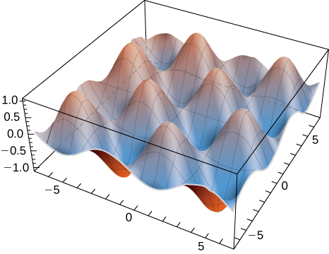

393. **[T]** By investing *x* units of labor and *y* units of capital, a watch manufacturer can produce  watches. Find the maximum number of watches that can be produced on a budget of  if labor costs $100/unit and capital costs $200/unit. Use a CAS to sketch a contour plot of the function.

Answer: Roughly 3365 watches at the critical point 

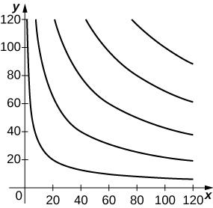

**Chapter Review Exercises**

**For the following exercises, determine whether the statement is *true or false*. Justify your answer with a proof or a counterexample**.

395. If the function  is continuous everywhere, then 

Answer: True, by Clairaut’s theorem

397.  is a critical point of 

Answer: False

**For the following exercises, sketch the function in one graph and, in a second, sketch several level curves.**

399. 

Answer: Answers may vary

**For the following exercises, evaluate the following limits, if they exist. If they do not exist, prove it.**

401. 

Answer: Does not exist

**For the following exercises, find the largest interval of continuity for the function.**

403. 

Answer: Continuous at all points on the  except where  .

**For the following exercises, find all first partial derivatives.**

405. 

Answer:     

**For the following exercises, find all second partial derivatives.**

407. 

Answer:         

**For the following exercises, find the equation of the tangent plane to the specified surface at the given point.**

409.  at point 

Answer: 

411. Find the differential  of  and approximate  at the point  Let and

Answer:  

413. Find the maximal directional derivative magnitude and direction for the function  at point 

Answer: 

**For the following exercises, find the gradient.**

415. 

Answer: 

**For the following exercises, use Lagrange multipliers to find the maximum and minimum values for the functions with the given constraints.**

417. 

Answer: maximum: minimum: 

419. A machinist is constructing a right circular cone out of a block of aluminum. The machine gives an error of  in height and  in radius. Find the maximum error in the volume of the cone if the machinist creates a cone of height  cm and radius  cm.

Answer:  cm3

This file is copyright 2016, Rice University. All Rights Reserved.